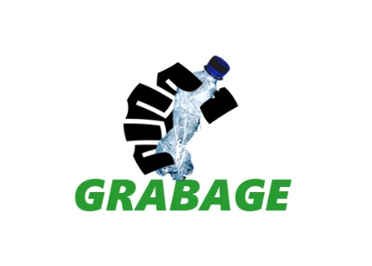Project Name: GRABAGE

Team Name: Sagada 17

Team Members:

Shaila Mae Choa

Miguel Paolo Magsino

Ezekiel Joy Perez

Juan Lorenzo Simeon

Jaylica Anne Tan

Contact Info: Juan Lorenzo Simeon - 09272519579

Shaila Mae Choa - 09333666282

Short Description:

It is a web application that can help the community dispose used plastic components for recycling. The users of the application can indicate their current amount of plastics collected where the registered recycling companies will request to buy the collected plastics.

Long Description:

The web application can allow the companies to choose where they will be buying their plastics from. Also, the recycling companies, plastic-molding companies, can also see the users who collect plastics, their current accumulated plastics and their contact information. The application will then notify the users in the community that the recycling companies want to buy the plastics that they had collected. It will notify the company the response of the users regarding the request.

Here are some benefits of the application:

* Proper waste management of used plastics
* Reduce wastes that can clog the sewers which is one of the main causes of flood
* The users can earn a small amount of income
* The companies will have alternative raw materials in making their plastic products
* More people can be more aware of saving the environment
* It will greatly help the environment

Screenshots:

